IRAMBA DISTRIC COUNCIL
FORM FOUR DISTRICT MOCK EXAMINATION 2023
CODE: 041 BASIC MATHEMATICS
MARKING SCHEME
- (a) Simplify the sum of 85% of 9861 and $\frac{3}{5}$ of 12458. Write your answer correct to two
significant figures.
1 mark
1 mark
1 mark
$\frac{85}{100}×9861+\frac{3}{5}×12458$
$8381.85+7474.8=15856.65$
$15856.65≈16000 in two significant figures$

(b) (i) Mr. Tumai Distributed Tshs 960,000/= awards to students who passed well in
their examinations and their respective teachers as follow: 22% to all students who passed Arts Subjects. 17% to students who passed Mathematics and 26% to students who passed science subjects. The remained amount was distributed to teachers. Required to Find the amount that were awarded to teachers.
22% + 17% + 26% + Teachers = 100%
1 mark
1 mark
1 mark
65% + Teachers = 100%
Teachers = 100% - 65%
Teachers = 35%
= $\frac{35}{100}×960,000=336,000$ ; Teachers were awarded Tshs. 336,000/=
(ii) Given time intervals: 8, 10 and 12 seconds
To find the time that 3 bells range together, we find the L.C.M of 8, 10 and 12 seconds; By prime factorization:
8 = 2$×$2$×$2
10 = 2 $×5$
12 = 2$×2×3$ 1 mark
L.C.M = 2$×2×2×3×5$
= 120 seconds or 2 minutes 1 mark
Time they will toll together is (50+2) minutes = 52 minutes or (120+3000) seconds = 3120 seconds. 1 mark

- (a) If $a=\sqrt{5}, b=\sqrt{3} , and c= \sqrt{2}$. Simplify $\frac{a-b}{b+c}$
$\frac{a-b}{b+c}=\frac{\sqrt{5}-\sqrt{3}}{\sqrt{3}+\sqrt{2}}$ By rationalizing the denominator
$$\frac{\sqrt{5}-\sqrt{3}}{\sqrt{3}+\sqrt{2}}=\frac{\sqrt{5}-\sqrt{3}}{\sqrt{3}+\sqrt{2}}×\frac{\sqrt{3}-\sqrt{2}}{\sqrt{3}-\sqrt{2}}$$

$$=\frac{\sqrt{15}-\sqrt{10}-3+\sqrt{6}}{3-\sqrt{6}+\sqrt{6}-2}$$
$$=\sqrt{15}-\sqrt{10}+\sqrt{6}-3$$
(b) 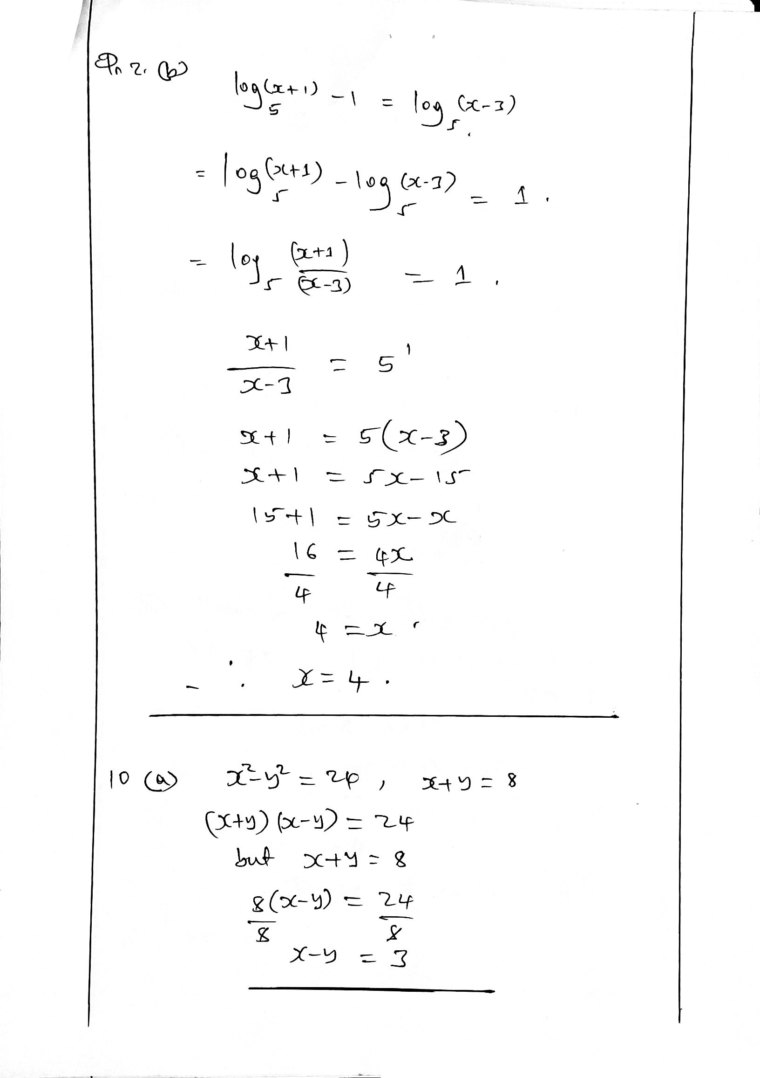
- In a certain class MSUVA displayed counting numbers less than 30. From the displayed numbers, OKWI mentioned all numbers completely divisible by 2 and FEITOTO mentioned all numbers that were the multiples of 3.

- (i) Outline all numbers that were mentioned by OKWI and FEITOTO in Common
0.5 marks
0.5 marks
0.5 marks
OKWI = {2, 4, 6, 8, 10, 12, 14, 16, 18, 20, 22, 24, 26, 28}
FEITOTO = {3, 6, 9, 12, 15, 18, 21, 24, 27}
Numbers mentioned in common = {6, 12, 18, 24}

(ii) How many numbers were mentioned BY Either OKWI or FEITOTO
0.5 marks
1 mark
n(OKWI U FEITOTO) = n(OKWI) + n(FEITOTO) – n(Common numbers)
n(OKWI U FEITOTO) = 14 + 9 – 4 =19

- A number was selected in random from the number displayed by MSUVA, Req. to find the probability that a selected number was a multiple of 3.
1.5 marks
1.5 marks
$$P\left( multiple of 3\right)=\frac{n\left( multiple of 3\right)}{n\left(Counting number less than 30\right)}$$
$$P\left( multiple of 3\right)=\frac{9}{29}$$
$p\left( multiple of 3\right)=\frac{9}{29}$
- (a) Given that $\underline{a}$= 4i + 3j and $\underline{b}$= 6i – 3j, Required to find the value of “h” and “k”
if h$\underline{a}$ + k$\underline{b}$ = 10i + j
given that $\underline{a}$ = 4i + 3j and $\underline{b}$ = 6i – 3j
h$\underline{a}$ + kb = h(4i + 3j) + k(6i – 3j)
= 4hi + 3hj + 6ki - 3kj (1mark)
Comparing h$\underline{a}$ + k$\underline{b}$ = 10i + j
4hi + 3hj + 6ki - 3kj = 10i + j
4hi + 6ki = 10i
4h+ 6k = 10 …………………… (i) (0.5 marks)
3hj -3kj = j
3h-3k=1 ………………………….(ii) (0.5 marks)
$Solving equation \left(i\right)and \left(ii\right)Simultaneously, h=1.2 and k=0.87$ (1 mark)
(b) A perpendicular line from the point P(2,-4) to the line meets the line at point Z(-1,3). Required to find:
i. Distance $\overline{PZ}$
$Distance \overline{PZ}=\sqrt{{\left(2+1\right)}^{2}+{\left(-4-3\right)}^{2}}=\sqrt{58}=7.615 unit of lengt$ (1.5 marks)
ii. If the point Z(-1,3) is a mid-point of the line $\overline{PQ}$, find the coordinates of point $Q$
$Midpoint= \left(\frac{x+2}{2},\frac{y-4}{2}\right)$
$\left(-1,3\right)=\left(\frac{x+2}{2},\frac{y-4}{2}\right)$ by comparing, we get; $\left(x,y\right)=\left(-4,10\right)$
$Hence Q\left(x,y\right)=(-$4,10) (1.5marks)

- (a) In the following figure; $\overline{ED}$//$\overline{BC}$ and $\overline{AB}=\overline{AC}$; If $\overline{AB}=13cm$ and $\overline{BC}=10cm$, find the Area of BCDE

0.5 mark
0.5 marks

0.5 marks
E
A
D
B
C
6.5cm
6.5cm
10cm
B$\hat{A}$C=E$\hat{A}$D (common Angle)
A$\hat{B}$C=A$\hat{E}$D (alternate angle $\overline{ED}$∕∕$\overline{BC}$)
B$\hat{C}$A=E$\hat{D}$A (alternate angle $\overline{ED}$∕∕$\overline{BC}$)
$ABC\sim AED$ (AAA)
$$Hence \frac{13}{6.5}=\frac{6.5}{\overline{ED}} and \overline{ED}=5cm$$
Consider the height from $∆ABC$
From Pythagoras theorem; $a^{2}+b^{2}=c^{2}$
$h^{2}={13}^{2}-5^{2}$
$h=12$
Area of $∆ABC=\frac{1}{2}×h×BC$
$$Area of ∆ABC=\frac{1}{2}×10×12$$
Area of $∆ABC=60{cm}^{2}$ 0.5 marks

From area of similar figures
Ratio of areas $k^{2}=\frac{A_{1}}{A_{2}}$ since $A_{1}=60{cm}^{2}$
${\left(\frac{10}{5}\right)}^{2}=\frac{60}{A_{2}}$
100A₂ = 60 $×25$
A₂ ₌ $=$ $\frac{1500}{100}=15{cm}^{2}$ 0.5 marks

Therefore $Area of BCDE=Area of ∆ABC- ∆AED$
Hence $Area of BCDE=60{cm}^{2}-15{cm}^{2}$
Area of BCDE = 45cm² 0.5 marks

(b) By considering the Alternating opposite angles theorem, required to draw the diagram hence identify the corresponding angles
1 mark

1 mark

1 mark
a
b
x
y
b = x
a = y
- (a) The time “t” taken to buy fuel at LAKE OIL PETROL STATION in Morogoro varies directly as the number of vehicle “V” in the queue and inversely as the number of pumps “P” available in the station. In petrol station with 10 pumps it takes 20 minutes to fuel 40 vehicles.
- Required to write vehicle “v” in terms of pumps “P” and time “t”
$t∝\frac{v}{p} which implies that t=k\frac{v}{p}$ (0.5 marks)
$v=\frac{pt}{k}$ (0.5 marks)
- Req. to find the time it will take to fuel 60 vehicles in a station with 4 pumps.
(1mark)
$From, t=\frac{kv}{p} this implies k=\frac{pt}{v}$ (1 mark)
$when p=10, t=20 and v=40 therefore k=\frac{10×20}{40}=5$ (1mark)
$$when v=60, p=4 and k=5, therefore t=\frac{5×60}{4}=75 minutes$$
(b) Mayele bought 3 bottles of juice of capacity 350 ml and Dialo bought 1 bottle of juice of capacity 1 litre.
i. required to find Who had more juice to drink.
$Mayele juice=3×350ml=1050ml=1.05 litres$
$Dialo juice=1 litre$ (1 mark)
$Mayele had more Juice to drink$
ii. required to find How much more
$amount=1.05 litres-1 litre=0.05litre=50 ml$ (1 mark)
- (a) Require to give the meaning of the following terms as used in Accounts
- Cash book: Is the book/account which records cash transactions only.
- Assets: Are properties or possessions of the business; For example buildings, motor vans, etc (1mark @)
- Credit transaction: Are transactions where by payments are done later.
(b) A company bought two cars for Tshs 25,000,000/= each. If one car was sold at a profit of 18% and another was sold at a loss of 6%. In the whole transactions there were no loss. What was the profit made by a company?
1 mark

1 mark
1 mark
$$Car 1:Profit=\frac{18}{100}×25,000,000=4,500,000$$
$$Car 2:Loss=\frac{6}{100}×25,000,000=1,500,000$$
$$Profit made=Profit of Car 1-Loss of car 2$$
$$=4,500,000-1,500,000=3,000,000$$
- (a) A BODA BODA driver rates after each kilometre. The fare is Tshs. 1000/= for the first kilometre and raise by Tshs. 500/= for each additional kilometre. If BALEKE want to travel 10 kilometres by BODA BODA. What will he be charged by BODA BODA driver?

$$First kilometre \left(A_{1}\right)=1,000$$
$$Amount added to preceeding \left(d\right)=500$$
Required to find charge (A₅₀) after travelling 50km (n = 10)
1 mark
1 mark
1 mark

$$A_{n}=A_{1}+\left(n-1\right)d$$
$$A_{10}=1,000+\left(10-1\right)500$$
$A_{10}=5,500$ Tshs.
(b) The number 19683 is in which term in the following Geometric sequence 3, 9, 27, …?
0.5 mark
0.5 mark
1 mark
1 mark
${G_{n}=19683,G}_{1}=3, r=3$ required to find number of terms “n”
$$G_{n}=G_{1}r^{n-1}$$
$$19683=3×3^{n-1}$$
$$6561=3^{n-1}$$
$$3^{8}=3^{n-1}$$
$$n-1=8, n=9$$
32768 is the Nineth term of the sequence
- . (a) If the square of the hypotenuse of an isosceles right-angled triangle is 128 cm² find the length of each other sides
let a side be x
1 mark
1 mark
1 mark
$$x^{2}+x^{2}=128$$
$$2x^{2}=128$$
$$x^{2}=64 , x=8cm$$
(b) From the top of a tower of height 60m the angles of depression of the top and the bottom of a building are observed to be 30⁰ and 60⁰ respectively. Find the height of the building.
1 mark

0.5 marks

0.5 marks
0.5 marks
0.5 marks
30⁰
30⁰
60⁰
30⁰
A
B
C
D
E
$$\overline{AD}=60m$$
$$\tan{{60}^{0}=\frac{\overline{AD}}{\overline{DC}}}=\frac{60}{\overline{DC}}$$
$$\overline{DC}=\frac{60}{\sqrt{3}}$$
Also, ${\tan{30}}^{0}=\frac{\overline{AE}}{\overline{BE}}=\frac{60-\overline{DE}}{\overline{BE}}$
$$\overline{BE}=\sqrt{3}\left(60-\overline{DE}\right)$$
But $\overline{DC}=\overline{BE}$
$$\frac{60}{\sqrt{3}}=\sqrt{3}\left(60-\overline{DE}\right)$$
$\overline{DE}=\overline{BC}=40cm$ height
- (a)

(b) A large rectangular garden in a park is 120m wide and 150m long. A contractor is called in to add a brick walkway to surround this garden by the same width. If the area of the walkway is 2800m², how wide is the walkway?
0.5 marks
0.5 marks

0.5 marks

1 mark
0.5 marks

120m
150m
$$x$$
$Area of small rectangle=120×150=18000$m²
$$Area of large rectangle= \left(120+2x\right)\left(150+2x\right)$$
But, $Area of large=Area of small+Area walkway$
$$\left(120+2x\right)\left(150+2x\right)=18000+2800$$
$$18000+540x+{4x}^{2}=18000+2800$$
$${4x}^{2}+540x-2800=0$$
$$x^{2}+135x-700=0$$
$$x=5 or x=-140$$
$$Since, Length≠negative value, x=5m$$
$$The walkway is 5m wide$$
- In certain research the data were summarized as shown in a table below:

Class Mark | 10 | 15 | 20 | 25 | 30 | 35
Frequency | 3 | 2 | 10 | 5 | 4 | 1
Required to reconstruct a frequency distribution table including class interval and frequency.
Let $a-b, be the first class interval. Then \frac{a+b}{2}=10$
$hence a+b=20……………………..(i)$ (0.5mark)
$$class Size=15-10=5 (Consecutive Classmarks)$$
$$But Also, Class Size=Upper boundary-Lower boundary$$
$$Class Size=b+0.5-a+0.5$$
$$5=b-a+1$$
$b-a=4…………………\left(ii\right)$ (1mark)
$Solving \left(i\right)and \left(ii\right) simultaneously we get a=8, b=12$ (1.5 mark)
$$The first interval is 8-12$$
interval | 8 – 12 | 13 – 17 | 18 – 22 | 23 – 27 | 28 – 32 | 33 – 37
Frequency | 3 | 2 | 10 | 5 | 4 | 1
(2 marks)
(b) Required to prove that equal chords of a circle subtend equal angles at a centre.
A
B
C
D
O
$chord \overline{AB}=chord \overline{DC} Given$ (1 mark)
$\overline{AO}=\overline{DO}=\overline{BO}=\overline{CO} radii$ (1 mark)
$∆AOB≡∆COD SSS$ (1 mark)
$Hence A\hat{O}B=C\hat{O}D$ (1 mark)
(1 mark)
- (a) Two towns P and Q on the Latitude 48⁰ are 370 Nautical miles apart. Find the
difference in their longitude.
$Nm Distance = \left(60θcosα\right)Nm$ (1 mark)
$$where θ=Difference in longtude \left(to be found\right)$$
$$and α=Latitude=48°N \left(Given\right)$$
$$Distance=370Nm \left(Given\right)$$
$Therefore, 370Nm= \left(60θ\cos{48°}\right)Nm$ (1 mark)
$θ=9.2°$ (1mark)
(b) A pyramid with vertex V and edges VA, VB, VC, VD each 15cm long has a rectangular base ABCD where AB = CD = 10cm and AD = BC = 8cm.
i. Sketch the pyramid using the above information.
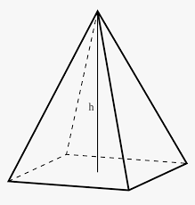
V
B
C
A
D
O
15cm
8cm
10 cm
1.5 marks
ii. Calculate the height “VO” of the pyramid where “O” is the centre of the rectangle.
$$Consider ∆AOV,$$
${\overline{VO}}^{2}+{\overline{AO}}^{2}={\overline{AV}}^{2} but \overline{AO}=\frac{1}{2}\overline{AC}$
${\overline{VO}}^{2}={15}^{2}-\frac{1}{4}{\overline{AC}}^{2}………………………..\left(i\right)$ (0.5 marks)
$$consider ∆ABC,$$
$$From Pythagoras theorem$$
$${\overline{AC}}^{2}={\overline{AB}}^{2}+{\overline{BC}}^{2}$$
${\overline{AC}}^{2}={10}^{2}+8^{2} hence {\overline{AC}}^{2}=164…………….\left(ii\right)$ (0.5 marks)
$$By Subst equation \left(ii\right)into \left(i\right)$$
$\overline{VO}=h=13.6cm$ (1mark)
- Calculate the angle between the base and edge
$$From ∆AOV, let θ represent the angle between \overline{VA} and \overline{AO}$$
$Then, Cos θ=\frac{\overline{AO}}{\overline{VA}}= \frac{\frac{\sqrt{164}}{2}}{15}$ (1mark)
$Hence θ=64.7°$ (0.5 marks)

- (a). (i). Find the possible values of x if the matrix $\left(\begin{matrix}x+1 & 9 \\ 3 & x+5\end{matrix}\right)$ has no inverse.
(ii). By using matrix method, solve the equations $\left\{\begin{matrix}4x-9=-3y \\ 5x-17-2y=0\end{matrix}\right.$
(i). Let A =$\left(\begin{matrix}x+1 9 \\ 3 x-5\end{matrix}\right)$
Since matrix A has no inverse
Then
|A| = 0 (0.5 marks)
So
$(x+1)(x-5) – (3x 9) =0$ expanding x² – 5x + x - 5 - 27=0 hence x² – 4x - 32=0
Solving quadratically we get (1mark)
X = 8 or -4
(ii). Given that $\left\{\begin{aligned}4x-9=-3y \\ 5x-17-2y=0\end{aligned}\right.$
Rearranging $\left\{\begin{aligned}4x+3y=9 \\ 5x-2y=17\end{aligned}\right.$
Let B =$\left(\begin{matrix}4 3 \\ 5 -2\end{matrix}\right)\left(\begin{matrix}x \\ y\end{matrix}\right)=\left(\begin{matrix}9 \\ 17\end{matrix}\right)$
|B| = -8 – 15 hence |B|= - 23 (0.5 marks)
B⁻¹ =$\frac{1}{-23}$ $\left(\begin{matrix}-2 -3 \\ -5 4\end{matrix}\right)$

B⁻¹ = $\left(\begin{matrix}\frac{2}{23} \frac{3}{23} \\ \frac{5}{23} \frac{-4}{ 23}\end{matrix}\right)$ (1mark)
Then
B⁻¹B = B⁻¹ $\left(\begin{matrix}9 \\ 17\end{matrix}\right)$
$\left(\begin{matrix}1 0 \\ 0 1\end{matrix}\right)\left(\begin{matrix}x \\ y\end{matrix}\right)$= $\left(\begin{matrix}2/{23} \\ 5/{23}\end{matrix} \begin{matrix}3/{23} \\ {-4}/{23}\end{matrix}\right)$ $\left(\begin{matrix}9 \\ 17\end{matrix}\right)$ (1mark)
$\left(\begin{matrix}x \\ y\end{matrix}\right)$= $\left(\begin{matrix}\frac{18}{23} \frac{51}{23} \\ \frac{45}{23} \frac{-68}{ 23}\end{matrix}\right)$
$\left(\begin{matrix}x \\ y\end{matrix}\right)$=$\left(\begin{matrix} \frac{69}{23} \\ \frac{-23}{ 23}\end{matrix}\right)$
$\left(\begin{matrix}x \\ y\end{matrix}\right)$ = $\left(\begin{matrix}3 \\ -1\end{matrix}\right)$ hence x = 3 and y = -1 (1mark)
(b). A transformation is given 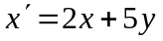 and 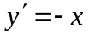, Required to find the image of the equation 2x – 3y = 6 under the transformation matrix which performs the above transformations.
Given
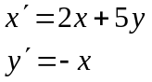
Then
The transaction matrix = $\left(\begin{matrix}2 5 \\ -1 0\end{matrix}\right)$ (1mark)
Required to find the image of 2x – 3y =.
Its x and y intercept points are:
A(0, -2) and B(3, 0).
Their images are obtain as
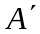=$\left(\begin{matrix}2 5 \\ -1 0\end{matrix}\right)$ $\left(\begin{matrix}0 \\ -2\end{matrix}\right)$ (1mark)
= (-10, 0)
Also
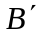 =$\left(\begin{matrix}2 5 \\ -1 0\end{matrix}\right)$ $\left(\begin{matrix}3 \\ 0\end{matrix}\right)$
=$\left(6,-3\right)$ (1mark)
M = $\frac{y_{2}-y_{1}}{x_{2}-x_{1}}$M =$\frac{-3-0}{6-(-10)}$ M=$\frac{-3}{16}$
Also to find equation
M=$\frac{\begin{matrix}y - & y_{0}\end{matrix}}{\begin{matrix}x - & x_{0}\end{matrix}}$M=$\frac{\begin{matrix}y - & 0\end{matrix}}{\begin{matrix}x – & (-10)\end{matrix}} such that$ $\frac{-3}{16}=\frac{y}{x+10}$ (1mark)
-3x – 30 =16y rearranging, -3x -16y = 30
Its image is 3x + 16y = -30 (1mark)

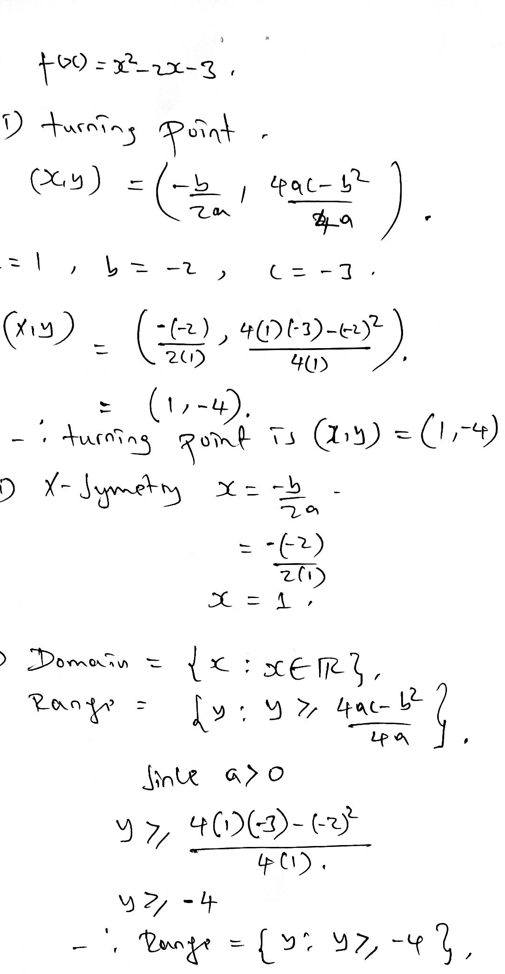
- (a)

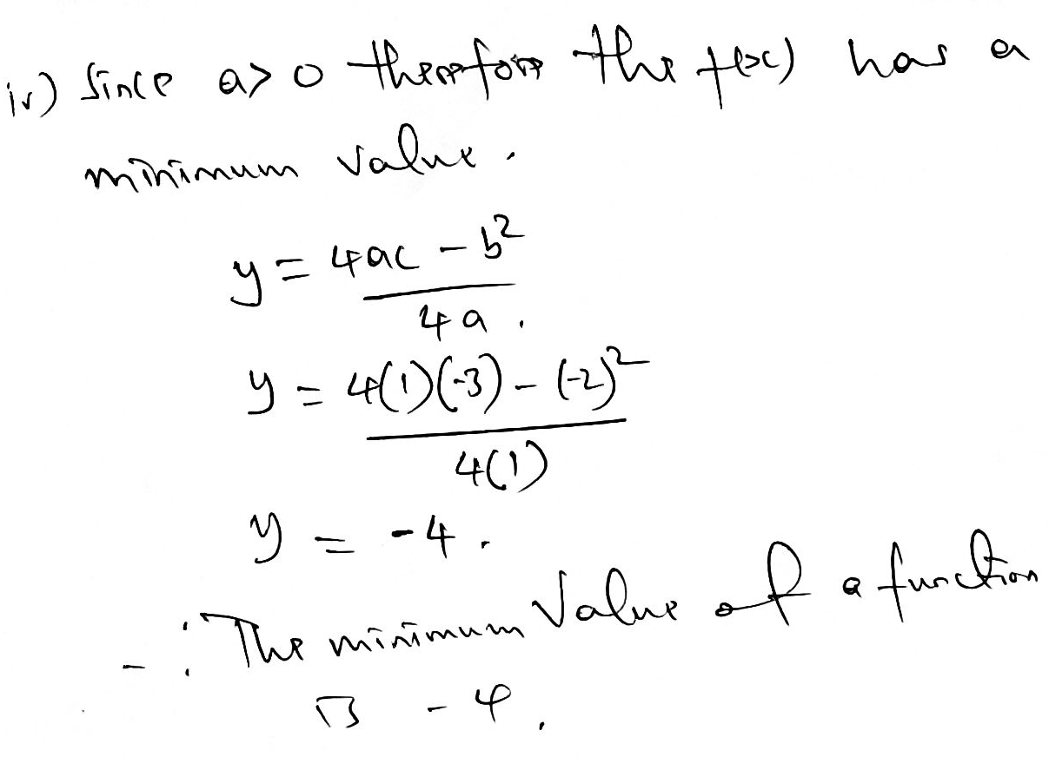

(b) A school is preparing a trip for 400 students. The company who is proving the
transportation has 10 buses of 50 seats each and 8 buses of 40 seats, but only 9 drivers available. The rental cost for a large bus is 800,000/= and 600,000/= for the small bus. How many buses of each type should be used for the trip for the least possible cost?
CONSTRAINTS
0.5 marks
0.5 marks
$$Eq1: 40x+50y≥400$$
$$Eq2: x+y≤9$$
$$Eq3: x≥0$$
$$Eq4: y≥0$$
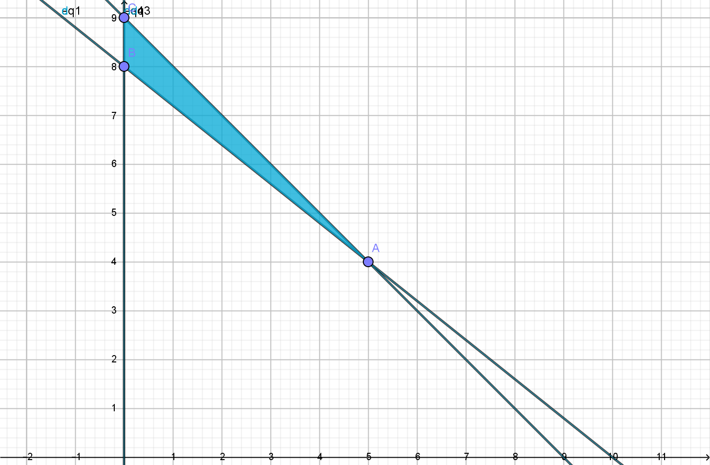
1 mark
1 mark

2 marks
$$A=(6,4)$$
$$B=(0,8)$$
$$C=(0,9)$$
$$Objective Function; F\left(x,y\right)=600,000x+800,000y$$
$$F\left(5,4\right)=6,200,000$$
$$F\left(0,8\right)=6,400,000$$
$$F\left(0,9\right)=7,200,000$$
$$Hence the minimum cost is 6,200,00, hence 5 small buses and 4 large buses should be used$$

